Part I: Interview
time:
4 minutes
time:
4 minutes

Teacher:
In the first part of this test, I am going to ask each of you some questions.
In the interview, I will ask each of you each question in the following way:
A, then B / B, then A / A, then B … and so on.
We will start when you are ready.

- What can you tell me about yourself and your family?

- Which is your favourite subject and why?

- Are there any subjects you don't like? Why?

- What kind of media do you use?

- Do you have any favourite film or series?

This is the end of this task.
_______________________________________________________________________
Part II: Monologue A

Teacher:

Now I'd like each of you to talk about pictures. You have about 2 minutes each.

Candidate A: You will start. Here is your material.
time:
2 minutes

- Describe one of the pictures.
- How might the person in the picture feel and why?
- What kind of food do you prefer?

Shall I repeat the instructions?

_______________________________________________________________________
Candidate B: Now it's your turn. Here is your material.
time:
2 minutes

- Describe one of the pictures.
- How might the people in the picture feel and why?
- In which situations do you prefer to use or not to use your smartphone and why?

Shall I repeat the instructions?
______________________________________________________________________________
Part III: Paired Discussion
time:
4 minutes
Teacher:

Now I'd like each of you to talk to each other.

You and your friend are planning a holiday in the USA. You can stay in a big city or in the country. Use the pictures to discuss the pros and cons of holidays in a big city or in the country.

Part II: Monologue A

- Describe one of the pictures.
- How might the person in the picture feel and why?
- What kind of food do you prefer?




- Describe one of the pictures.
- How might the people in the picture feel and why?
- In which situations do you prefer to use or not to use your smartphone and why?



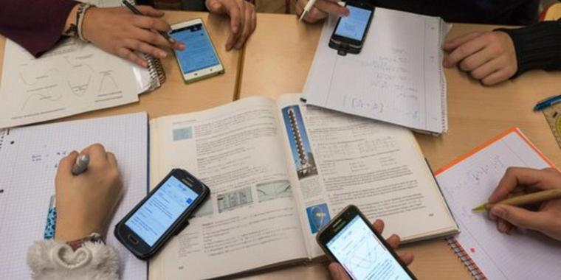

Part III: Paired Discussion

You and your friend are planning a holiday in the USA. You can stay in a big city or in the country. Use the pictures to discuss the pros and cons of holidays in a big city or in the country.




